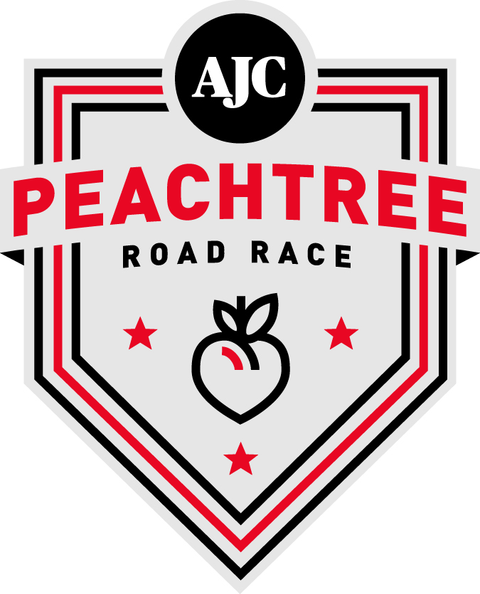

FOR IMMEDIATE RELEASE:

Media Contact:
Amanda Kowaleski
404-231-9064 ext. 104
akowaleski@atlantatrackclub.org

Olympic and World Champion Marathoners Vie for 2016 Peachtree Title
Top male and female at AJC Peachtree Road Race will earn spots on the Peachtree Cup trophy

ATLANTA – June 14, 2016 – A rematch of the closest finish in the history of the AJC Peachtree Road Race, the best women’s marathon runners in the world and a U.S. Olympian coached by a Peachtree champion headline the elite fields at the 47th AJC Peachtree Road Race on July 4 in Atlanta.

In the closing meters of last year’s race, Ben Payne (Colorado Springs, CO), pumped his fist to celebrate what appeared to be an inevitable win only to be chased down by Scott Overall (Great Britain). The image of the British distance star leaning at the line to break the tape and steal the victory from the U.S. Air Force pilot was seen around the world.

The Brit and American will battle it out again this Independence Day. They will be joined on the starting line of the world’s largest 10K by U.S. Olympic Marathon team member Jared Ward (Provo, UT). Ward, who placed third at the Olympic Marathon Trials in February, will compete as part of his buildup for the Olympic Marathon in Rio de Janeiro, Brazil, this August.

“The Olympic games are the big prize” said Ward, whose coach Ed Eyestone won the 1991 AJC Peachtree Road Race. “But my road to Rio will go through Atlanta on July 4.”

Two-time World Marathon Champion Edna Kiplagat (Kenya) leads a group of the world’s best marathoners who will step down in distance to vie for the title in the women’s elite race.

Kiplagat, who has also won the London, New York City and Los Angeles Marathons, will face fellow Los Angeles Marathon winner Buzunesh Deba (Ethiopia). Kiplagat and Deba are two of just 20 women in history to break 2:20 in the marathon. Also competing will be Kim Smith who holds New Zealand’s national record in the marathon. Smith has competed in three Olympic Games at three different distances (5,000m, 10,000m and marathon).

Neely Spence Gracey (Boulder, CO) will attempt to claim victory for the United States. Gracey is racing for the first time since finishing as top American in the 2016 Boston Marathon, her debut at that distance.

“Being part of the world’s largest 10K where so many people are celebrating the sport of running is going to be an incredible experience,” said Gracey, whose father won a bronze medal at the World Marathon Championships in 1991.

The top man and woman to cross the finish line will have their names engraved in the Peachtree Cup. They will also take home $7,500 each, part of the overall prize purse of $57,000.

A full list of elite athletes competing in the 2016 AJC Peachtree Road Race will be released in the coming weeks.

The 47th running of the AJC Peachtree Road Race will take place on Monday, July 4, 2016. The AJC Peachtree Road Race is the world’s largest 10K with 60,000 participants.

For more information, visit peachtreeroadrace.org.

About Atlanta Track Club
Atlanta Track Club is a nonprofit committed to creating an active and healthy Atlanta. Through running and walking, Atlanta Track Club motivates, inspires and engages the community to enjoy a healthier lifestyle. With more than 24,000 members, Atlanta Track Club is the second largest running organization in the United States. In addition to the AJC Peachtree Road Race (peachtreeroadrace.org) – the largest 10K running event in the world, the Publix Georgia Marathon, Atlanta 10 Miler and Thanksgiving Day Half Marathon, Atlanta Track Club directs more than 30 events per year. Through the support of its members and volunteers, Atlanta Track Club also maintains a number of community initiatives including organizing and promoting the Kilometer Kids youth running program to metro Atlanta youth, honoring high school cross country and track and field athletes through Atlanta Track Club’s All-Metro Banquets and supporting the Grady Bicycle EMT program. For more information on Atlanta Track Club, visit atlantatrackclub.org.

About the AJC Peachtree Road Race
The AJC Peachtree Road Race is a 10K event that takes place every Fourth of July in Atlanta, Georgia. The first Peachtree was held in 1970 and featured 110 finishers. The AJC Peachtree Road Race is now the largest 10K running event in the world with 60,000 participants. The AJC Peachtree Road Race is perhaps most famous for the coveted AJC Peachtree Road Race T-shirt, which is handed out to all the event finishers. For more information on the AJC Peachtree Road Race visit peachtreeroadrace.org or AJC.com/peachtree.

About The Atlanta Journal-Constitution
The Atlanta Journal-Constitution is the leading source – both in print and online – of news, information and advertising for metropolitan Atlanta, reaching a total print and online audience of 1.7 million people each week. Every month, nearly 6.4 million unique visitors access the newspaper's websites, including AJC.com, myAJC.com and accessAtlanta.com. The Atlanta Journal-Constitution is part of Cox Media Group, a publishing, digital media and broadcasting subsidiary of Atlanta-based Cox Enterprises.

###

